- Download the 'Spotify Top 50 Songs' dataset from Kaggle, load it into a pandas DataFrame, and identify which columns should be used as features and which as the label if you want to predict a song's popularity score.

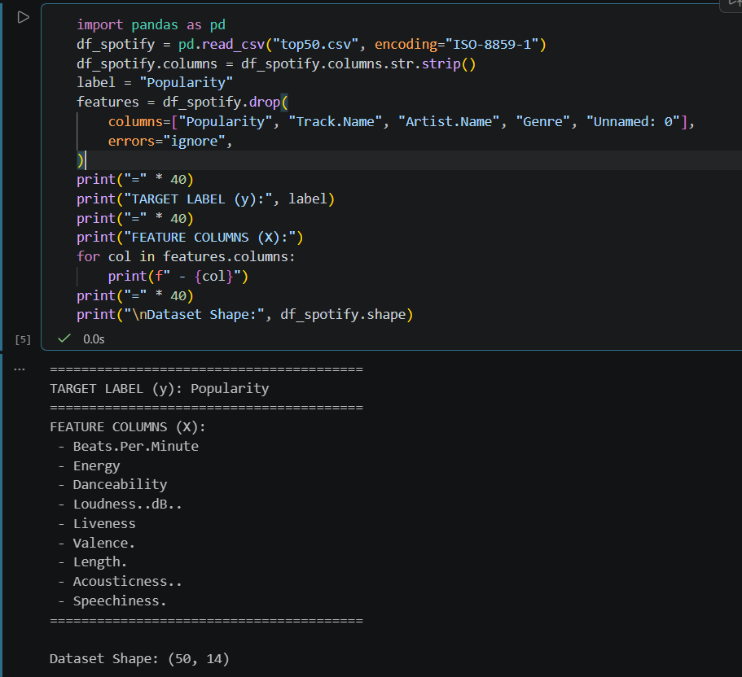

===========================================================================

- Split the loaded Spotify dataset into training and test sets using sklearn's train_test_split function, with 80% for training and 20% for testing. Print the number of rows in each set.

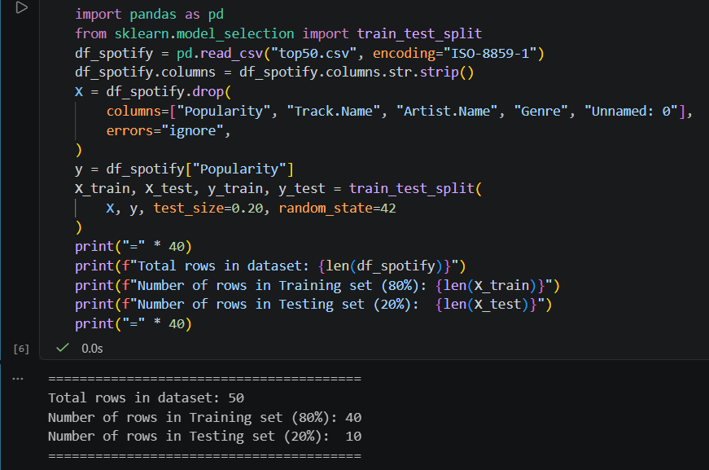

===========================================================================

- Given a simple linear regression model predicting song popularity from danceability, intentionally use only 5% of the data for training and 95% for testing. Observe the model's performance and explain whether this is likely to cause underfitting or overfitting.<br><br><em><strong>Hint:</strong> Look at the accuracy or error on both train and test sets to support your answer.</em>
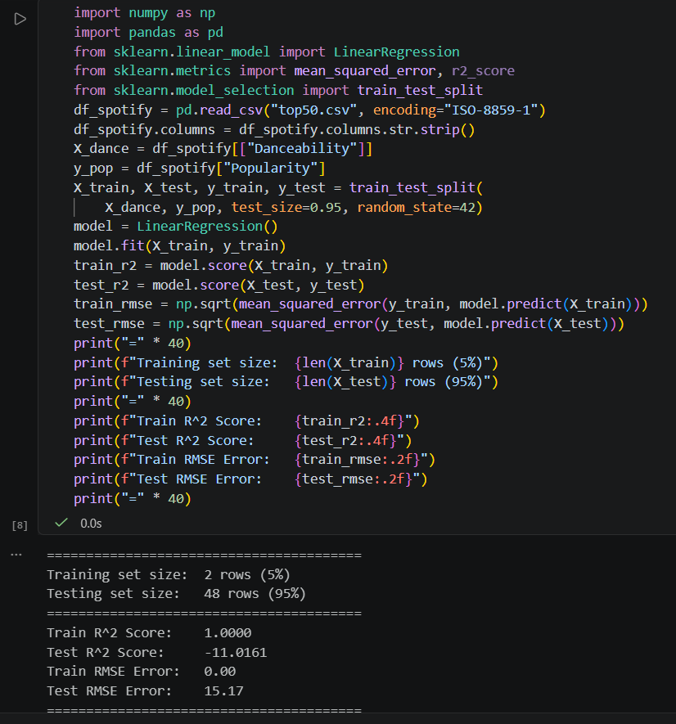

===========================================================================

- Draw or find a graph online that visually explains the bias–variance tradeoff, and write a short note describing how this tradeoff would affect predictions in a Zomato restaurant rating predictor app.
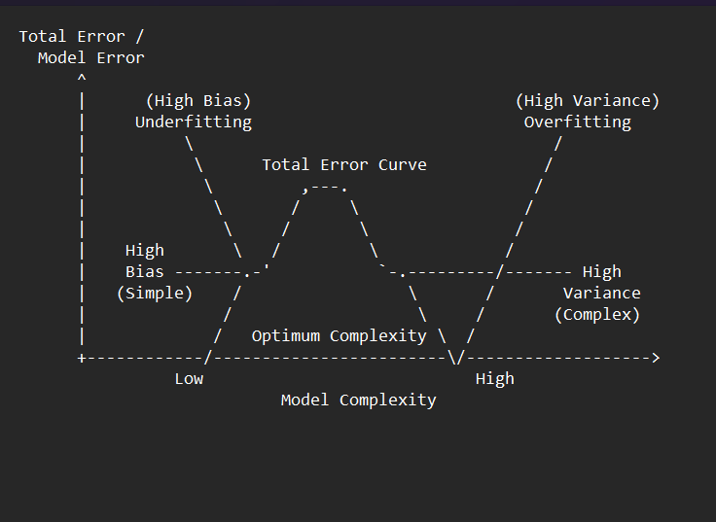
In a machine learning model built to predict a restaurant's rating on Zomato, the tradeoff operates as follows:
- High Bias (Underfitting):
  - Scenario: The model relies on an overly simplistic assumption—for example, predicting a restaurant's rating based only on its average_cost_for_two.
  - Impact: It misses key signals (like cuisine quality, delivery speed, or review volume). It performs poorly and gives inaccurate predictions for both training data and new restaurants added to Zomato.
- High Variance (Overfitting):
  - Scenario: The model is overly complex (e.g., an unconstrained deep decision tree using hyper-specific features like exact_building_number or obscure words from individual user reviews).
  - Impact: It memorizes noise and specific details in the training dataset. It achieves near-perfect accuracy on existing training restaurants but fails completely when predicting ratings for newly opened restaurants on Zomato.
- The Tradeoff (Optimal Balance):
  - The goal is to find the sweet spot where the model balances complexity by incorporating key, generalizable features (such as location_zone, cuisine_type, delivery_rating, and price_range) to achieve the lowest possible total prediction error on unseen data.

=====================================================================

- Give a real example (outside of healthcare/hospital) of overfitting from any app you use (e.g., Instagram, Flipkart, Swiggy), and explain in 2-3 lines why it might happen in that scenario.

Real-World Example: Instagram / Flipkart Recommendation Algorithm

Scenario: An algorithm on Instagram (or Flipkart) tracks a user who accidentally clicks on a single video about woodworking (or searches once for a mosquito net on Flipkart) and immediately floods their entire Explore feed / homepage with that exact niche content for the next two weeks.

Why It Happens (Explanation)

Explanation: The recommendation model overfits to sparse, short-term interaction data (a single click or search noise point). Instead of capturing broader, long-term user preferences, it over-indexes on immediate historical signals and mistakes a one-time curiosity for a permanent user trait.

